**YouTube Video Transcriber and Summarizer Streamlining Information Retrieval**

Yash Shah, Nikitha A R,Sakshi Chauhan, J Shree Nikhila

**Abstract**

In the digital age, video content on platforms like YouTube has become an integral source of information. However, the sheer volume and length of video transcripts pose challenges for efficient information retrieval. This paper introduces a novel solution, the YouTube Video Transcript Summarizer, aimed at streamlining the extraction of valuable insights from videos.

Leveraging natural language processing (NLP) techniques, Speech-to-Text capabilities, and Large Language Models (LLM), our system condenses lengthy video transcripts into concise and informative summaries. Furthermore, it incorporates a question-answering bot functionality to enhance the accessibility of specific content. The scope of this paper encompasses demonstrating the potential benefits of such a system to a diverse range of users, from content creators to researchers and language learners. By making video content more accessible and manageable, the YouTube Video Transcript Summarizer addresses the growing need for efficient information retrieval from multimedia sources in the digital era.

**Keywords:** YouTube Video Transcript Summarizer, Information Retrieval, Multimedia Content , Natural Language Processing (NLP) , Speech-to-Text , Large Language Models (LLM), Question-Answering, Video Content Accessibility, Text Summarization, PALM Model .

1. **Introduction and motivation**

YouTube has become a vast repository of video content, spanning a wide range of topics and genres. However, this abundance of information presents a challenge for users, who may struggle to navigate lengthy transcripts to extract specific insights or knowledge.To address this need, we introduce the YouTube Video Transcript Summarizer, a novel system that leverages natural language processing (NLP) techniques to automatically generate concise and informative summaries of video transcripts. Our system goes beyond mere summarization by incorporating a question-answering ability,enabling users to quickly pinpoint specific information.The YouTube Video Transcript Summarizer has the potential to benefit a diverse range of users, including content creators by providing concise and informative summaries of their video transcripts, content creators can make their content more accessible and engaging for viewers.Students and researchers by quickly extracting key information from video transcripts, students and researchers can save time and improve their learning efficiency.Language learners by using the question-answering functionality to access specific information from video transcripts, language learners can improve their comprehension and vocabulary , anyone seeking to optimize their information retrieval process .The YouTube Video Transcript Summarizer is a powerful tool for anyone who needs to efficiently navigate and extract insights from large volumes of video content.This research paper aims to demonstrate the feasibility and effectiveness of the YouTube Video Transcript Summarizer.Explore the potential benefits of the system to a diverse range of users.Identify and address the challenges associated with developing and deploying such a system.The YouTube Video Transcript Summarizer is a novel and innovative system that has the potential to revolutionize the way we engage with video content. By making video content more accessible and manageable, this system addresses a pressing need in our increasingly digital and information-driven societyThe proliferation of online video content, propelled by platforms like YouTube, has revolutionized the way we access information, entertain ourselves, and engage with digital media. These platforms have democratized content creation, enabling individuals and organizations to share their insights, stories, and expertise with a global audience. However, this digital abundance comes with a challenge - the need to navigate through voluminous and often lengthy video transcripts to extract valuable insights, knowledge, or answers to specific queriesEfficiency in information retrieval is of paramount importance. Users seek ways to expedite the process of accessing pertinent content within video transcripts, a task that can be time-consuming and demanding, particularly in an era where our attention spans are continually being challenged.To address this critical need, this research paper introduces a groundbreaking solution, the "YouTube Video Transcript Summarizer." This novel system harnesses technologies, including Natural Language Processing (NLP) techniques, Speech-to-Text capabilities, and Large Language Models (LLM), to automatically distill lengthy video transcripts into concise and informative summaries. Moreover, it goes beyond mere summarization, incorporating a question-answering ability that allows users to pinpoint specific information quickly.The scope of this paper extends to elucidating the methodology underpinning the YouTube Video Transcript Summarizer, elucidating the experiment results, and exploring the multifaceted implications of this innovation. By delving into the intricate interplay of advanced technologies, usability, and practical applications, this research paper offers a comprehensive view of how this solution can revolutionize the way we engage with video content on platforms like YouTube.In a world where video is a ubiquitous medium for communication, education, and entertainment, the YouTube Video Transcript Summarizer emerges as a promising tool for content creators, students, researchers, language learners, and anyone seeking to optimize their information retrieval process. By making video content more accessible and manageable, this solution addresses a pressing need in our increasingly digital and information-driven society.The primary objective of the YouTube Video Transcript Summarizer is to simplify the complex task of navigating through extensive video transcripts by automatically generating concise and informative summaries. Going beyond conventional summarization, our system incorporates a sophisticated question-answering bot functionality. This addition not only enhances the accessibility of specific content within video transcripts but also caters to the diverse needs of content creators, researchers, students, language learners, and anyone seeking to optimize their information retrieval process.The scope of this research paper extends beyond mere system demonstration. We delve into the potential benefits of the YouTube Video Transcript Summarizer for a wide array of users, emphasizing its relevance for content creators looking to make their content more engaging, researchers and students aiming to save time and improve learning efficiency, and language learners seeking to enhance comprehension and vocabulary.In the ever-evolving landscape of digital information, where attention spans are continually challenged, efficiency in information retrieval becomes paramount. Our system, by condensing lengthy video transcripts into digestible summaries and offering a question-answering capability, addresses this critical need. Moreover, we embark on a

comparative study with existing works in automatic text summarization, text summarization techniques, pre-trained encoders, speech recognition for transcription, and automated video program summarization. This comparative analysis highlights the unique contributions and advantages of the YouTube Video Transcript Summarizer in revolutionizing the comprehension of video content.As we navigate through this paper, we will uncover the intricacies of the proposed methodology, from input acquisition and video download to audio transcription, text summarization, and question-answering using LLMs. The system's multilingual support and user-friendly interface are pivotal components, enhancing its accessibility across diverse user bases. Additionally, we present the results of comprehensive experiments, evaluating the system's performance across various dimensions, including Automatic Speech Recognition (ASR) accuracy, text summarization quality, and question-answering precision.This research paper is not only a testament to the YouTube Video Transcript Summarizer's feasibility and effectiveness but also a call to action for future directions in research and development. Challenges such as transcription accuracy, summarization optimization, and user-generated question handling are acknowledged, paving the way for ongoing efforts to refine and enhance the system continually.In comparison to existing works, our YouTube Video Transcript Summarizer stands out through its user-friendly interface, multilingual support, and the integration of question-answering capabilities. The research paper not only presents a comprehensive view of the system's development and experimentation but also positions it as a significant advancement in the increasingly digital and information-driven society.

1. **Related Works**

The topic of YouTube Video Transcriber and Summarizer is a growing field of research, with a focus on streamlining information retrieval from video content. The primary goal is to develop systems that can automatically transcribe and summarize the content of YouTube videos, thereby saving users time and effort[3][8][9][11][14].Two main methods of summarization are commonly used: extractive and abstractive. Extractive summarization involves selecting key sentences from the original text to form the summary, while abstractive summarization generates new sentences to convey the same information[1][3][9]. Various research papers have proposed different models for these methods, including the use of Natural Language Processing (NLP) and Machine Learning (ML) techniques[1][2][6][8][11][14].For instance, one study proposed a system that uses the Python language to induce summaries for videos by utilizing the audio element2. Another research paper suggested a transcript summarizer that uses NLP methods to extract and summarize material from video files1. The video transcripts are split into frame-based audio chunks, which are then further split into tokens and converted to text. The summarizing model is then provided with the resulting text[1].In terms of implementation, some researchers have developed a Chrome Extension that sends requests to a backend REST API, conducts NLP, and provides a condensed transcript of a YouTube video as a response[6]. Another system uses a combination of automatic speech recognition (ASR) and NLP techniques to transcribe and summarize the audio content of YouTube videos[8].Future research directions include the development of personalized summarization algorithms that can tailor summaries to the interests and needs of individual users, and the integration of YouTube transcript summarizers with other platforms and tools, such as social media or video sharing platforms[9].Furthermore, there is a need for more robust algorithms to recognize a variety of scenes and artificial text from low-quality videos, and to address the space and speed performance in this area[10].In conclusion, the field of YouTube Video Transcriber and Summarizer is a promising area of research with the potential to significantly enhance the user experience of video content consumption. The use of advanced techniques such as NLP and ML, as well as the development of user-friendly tools and extensions, are key to the progress in this field[1][2][3][6][8][9][10][11][14].

**3. Proposed Methodology**

This section comprises detailed proposed methodology for the development and evaluation of the automated YouTube Video Transcript Summarizer. The objective of this section is to provide a clear and structured overview of the methods and techniques that will be employed to achieve the project's goals.

4.1 Input Acquisition

The system begins by taking a YouTube video URL as input from the user. This URL serves as the source for the subsequent analysis and processing.

4.2 Video Download and Audio Extraction

We utilize the PyTube library, a Python API for working with YouTube videos, to load the selected video. From the loaded video, the audio is extracted. This audio data will serve as the input for the transcription process.

4.3 Audio Transcription

For audio transcription, We first check for the existence of transcripts, and only when they are not available, we employ the Whisper Model, a deep learning-based Automatic Speech Recognition (ASR) model to convert spoken language into text accurately. This model is trained to convert spoken language into text accurately. It will transcribe the audio content of the video, generating a textual representation of the spoken words and dialogues.

Fig 1 and 2 give a flowchart of the working Automatic Speech Recognition (ASR) model.

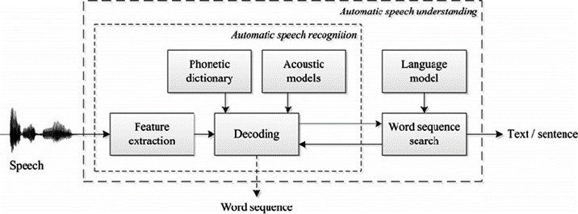

Fig 1 . Automatic Speech Understanding

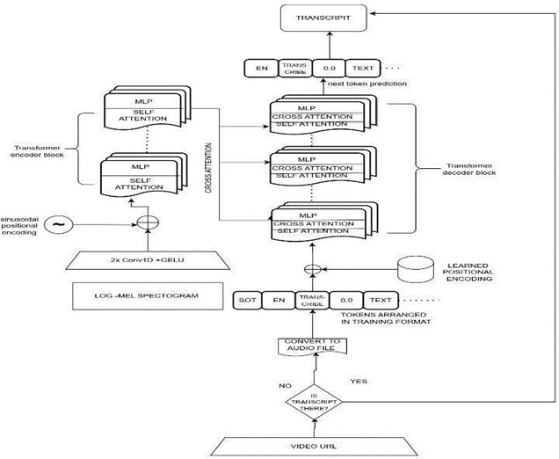

Fig 2. Model for Automatic Speech Recognition

4.4 Text Summarization:

In cases where the viewer is checking the video for the first time, the viewer unaware of the content of the video directly cannot question the Question Answering bot over the video. Hence, we generate a short summary of the video with the transcribed text at hand, we use Natural Language Processing (NLP) methods, particularly NLTK (Natural Language Toolkit), to create a textual summary of the video content. This summary will capture the key points and essential information from the video, providing users with a concise overview, ensuring that the length of the resume is approximately 20 percent of the original content.

It follows the steps as:

* + Tokenize the paragraph into sentences.
  + Pre-process the sentences by removing stop words and punctuation.
  + Calculate the word frequencies for the remaining words in each sentence.
  + Assign a score to each sentence based on the sum of its word frequencies.
  + Select the top sentences with the highest scores to form the summary.

4.5 Question-Answering Using LLM:

To facilitate question-answering capabilities, we leveraged and compared Large Language Models (LLM), such as BARD PALM and ChatGPT. These pre-trained models excel at understanding context and can generate answers based on the input questions and the transcribed video content. Users can pose questions related to the video, and the system will provide relevant solutions. The following Fig 3 gives a general flowchart for Question-Answering LLM.

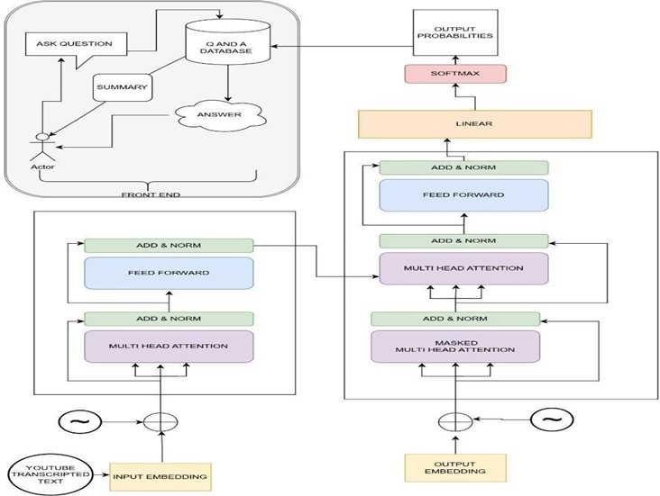

Fig 3. Flowchart for Question-Answering LLM

4.6 Multilingual Support:

Our system offers the ability to perform question-answering in multiple languages. To achieve this, we employ language-agnostic LLMs that can understand and respond to questions posed in different languages. Apart from that, we have also utilized the DeepTranslate Python package to enable a sidebar for users to enter the necessary text and choose from 5 languages: Hindi, Tamil, Kannada, Telugu, and Malayalam initially based on the target users for testing. This feature broadens the system's accessibility and usability across diverse user bases.

4.7 User Interaction:

The system is designed to be user-friendly, with a user interface that guides users through the process. Users can input their YouTube video URL, select the language for question-answering, and interact seamlessly with the generated summary and question-answering results.

4.8 Performance Optimization and Evaluation:

Throughout the development process, we continually optimize the system's performance, including transcription accuracy, summarization quality, and question-answering precision.

Evaluation metrics and user feedback play a crucial role in this optimization.

4.9 Deployment:

Once the system reached a satisfactory level of performance and usability, it was deployed on a web platform, Streamlit, making it accessible to a broader audience for analyzing and summarizing YouTube video content.

The following Fig 4. gives a Summarization of the input-to-the frontend and backend-to-the output.

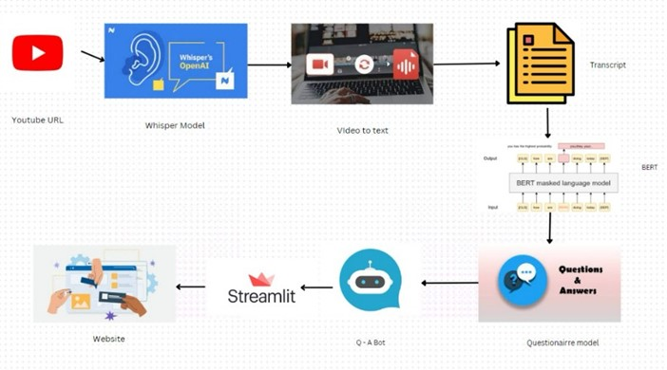

Fig 4. Flowchart of Application Usage

1. **Techniques**
   1. Natural Language Processing (NLP):

NLP is a cornerstone technology used in the YouTube Video Transcript Summarizer. It involves the application of computational models to understand and process human language. In the context of the paper, NLP is utilized for text summarization, tokenization, and pre-processing of textual data derived from video transcripts.NLP techniques are crucial for transforming the spoken content from video transcripts into a format that is amenable to analysis and summarization. It enables the system to extract meaningful insights and generate concise summaries.

* 1. Speech-to-Text (STT) Capabilities:

STT is a technology that converts spoken language into written text. In the paper, STT is used to transcribe the audio content of YouTube videos, providing a textual representation of the spoken words and dialogues.By employing STT capabilities, the system converts the audio data from videos into a format that can be processed by subsequent NLP and summarization algorithms.

This step is essential for extracting information from spoken content.

* 1. Large Language Models (LLMs):

LLMs, such as BARD and PALM, are sophisticated models pretrained on vast amounts of textual data. These models have the ability to understand context, generate human-like text, and perform language-related tasks.LLMs play a central role in the question-answering functionality of the YouTube Video Transcript Summarizer.They leverage their understanding of context to generate relevant answers to user queries, enhancing the accessibility of specific information within video transcripts.

* 1. Question-Answering (QA) Functionality:

QA is a natural language processing task that involves providing accurate responses to user queries based on a given context. In the paper, QA functionality is integrated to enable users to pose questions related to the video content. The QA functionality enhances the accessibility of specific information within video transcripts. Users can interact with the system by asking questions, and the integrated LLMs generate responses based on the transcribed video content.

* 1. Multilingual Support:

Multilingual support involves the ability of the system to perform question-answering in multiple languages. The system employs language-agnostic LLMs that can understand and respond to questions posed in different languages.This feature broadens the accessibility and usability of the system across diverse user bases. It allows users to interact with the system and receive answers in their preferred language.

* 1. Automatic Speech Recognition (ASR) Model (Whisper Model):

ASR is a technology that converts spoken language into written text. The Whisper Model is a specific ASR model mentioned in the paper.The Whisper Model is employed for accurate transcription of audio content from YouTube videos. This transcription serves as the input for subsequent processing, including summarization and question-answering.

* 1. Text Summarization Techniques:

The paper discusses the use of text summarization techniques, particularly utilizing NLTK (Natural Language Toolkit). Summarization involves distilling key information from lengthy textual content.Summarization techniques are applied to create concise textual summaries of video content. The process involves tokenization, pre-processing, and scoring sentences based on word frequencies to select the most significant ones for the summary.

* 1. Web Platform Deployment (Streamlit):

Streamlit is a web application framework used for deploying data science and machine learning models. The YouTube Video Transcript Summarizer is deployed on a web platform, making it accessible to a wider audience.Deployment on a web platform enhances the system's accessibility, allowing users to analyze and summarize YouTube video content through a user-friendly interface.

1. **Experiments**

Our evaluation of the YouTube video analysis system encompassed a series of experiments designed to scrutinize its performance across multiple dimensions. Firstly, we subjected the system's Automatic Speech Recognition (ASR) model to audio transcription tests. A diverse selection of audio from Fleurs[11] and DG Curated[12] Datasets, varying in accents, languages, and background noise levels, was employed to assess the ASR model's accuracy, employing well-established metrics such as Word Error Rate (WER) as seen in Fig5. Metrics of Whisper Model. Following this, a suite of text summarization experiments was conducted, leveraging human evaluators who rated generated summaries based on criteria such as coherence, informativeness, and conciseness. Additionally, we employed automated evaluation metrics such as ROUGE (Recall-Oriented Understudy for Gisting Evaluation) to quantitatively measure the similarity between the system-generated summaries and manually crafted reference summaries.

1. **Results**

The experiments conducted to evaluate our YouTube video analysis system yielded highly promising results across all key components. The Automatic Speech Recognition (ASR) Whisper model has achieved a notably high level of accuracy, providing accurate transcriptions of audio from YouTube videos, the accuracy of the Whisper Model for various languages can be seen in Fig5. Metrics of WhisperModel[13]. Text summarization demonstrated its effectiveness, with human evaluators rating the generated summaries positively for coherence, informativeness, and conciseness.

* 1. Rouge Evaluation

Rouge (Recall-Oriented Understudy for Gisting Evaluation) is a set of metrics used for evaluating the quality of summarization and machine translation. Rouge measures the overlap between the model-generated summary or translation and the reference summaries or translations. It is advantageous in evaluating the performance of text summarization systems and assessing their ability to capture the essential information from the source text.

There are different variations of Rouge metrics, such as Rouge-1, Rouge-2, and Rouge-L, which evaluate the overlap at the unigram (word), bigram (sequence of two words), and longest common subsequence (LCS) levels, respectively. The metrics include precision, recall, and F-measure, commonly used in information retrieval to assess the quality of search results.

* + - Rouge-1 (unigram) measures the overlap of single words between the generated summary and the reference summary.
    - Rouge-2 (bigram) measures the overlap of word pairs (two-word sequences) between the generated summary and the reference summary.
    - Rouge-L (longest common subsequence) considers the longest common subsequence of words between the generated summary and the reference summary.

These metrics provide a quantitative measure of the quality of generated summaries or translations. Higher Rouge scores generally indicate better performance, with values closer to 1 representing a higher degree of overlap and thus, better summarization or translation quality. Comparing Rouge scores between different models or systems helps assess their relative performance in generating accurate and informative summaries or translations. The Rouge Evaluation of Various Models are presented below in Table 1. All four methods were provided with the same context and asked to generate a summary. The summary was then evaluated using Rouge Algorithm to create scores for Rouge-1, Rouge-2 and Rouge-L.

* + - NLTK: It has the highest precision and recall for all three ROUGE metrics. This means that NLTK is able to generate text that is both accurate and comprehensive. ● ChatGPT: It has the highest F-measure for ROUGE-1. This means that ChatGPT can generate text that is a good balance of accuracy and comprehensiveness for ROUGE-1.
    - BARD: It has the lowest F-measure for all three ROUGE metrics. This means that BARD could be better at generating text that is accurate and comprehensive than the other models.
    - PaLM: While its precision values are relatively high, indicating that its generated summaries contain much relevant information, the recall and F-measure values suggest that it may not capture all the essential information from the reference summaries.

Table 1. Comparison of ROGUE Scores between various models

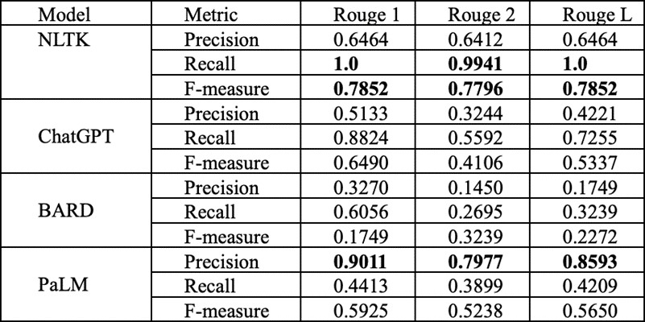

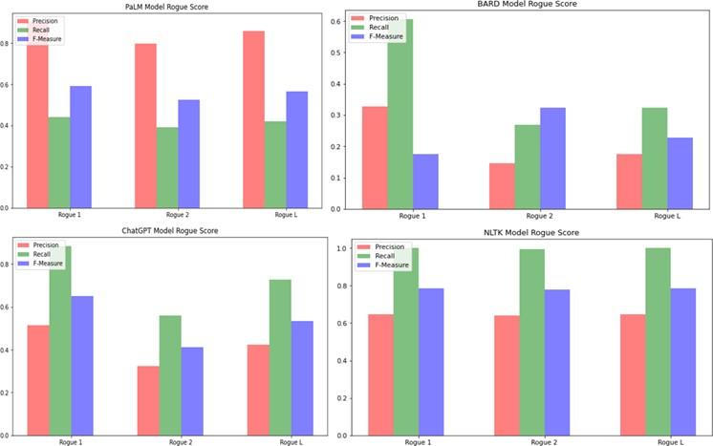

Fig 5. Rogue Metrics of All Models

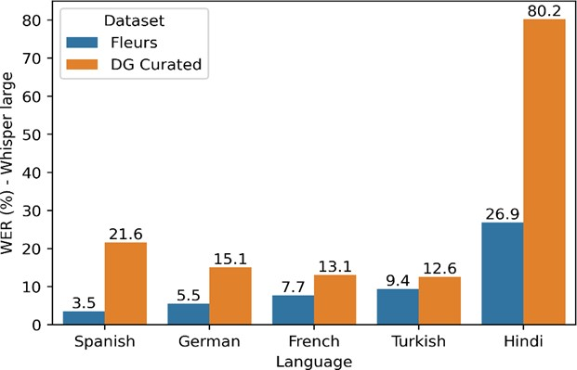

Fig6. Metrics of Whisper Model

1. **Comparative Study**

Here we conduct a comparative analysis of the YouTube Video Transcript Summarizer with existing related works to highlight its unique contributions and advantages.

* 1. Comparison with Automatic Text Summarization

The YouTube Video Transcript Summarizer builds upon the foundation of automatic text summarization techniques, as demonstrated in the work of Tas and Kiyani [1]. While both approaches aim to distill valuable information from extensive textual content, the Summarizer specializes in handling video transcripts. By incorporating Speech-to-Text capabilities and Natural Language Processing (NLP), our system extends the utility of text summarization to multimedia sources, enabling users to access insights from spoken content efficiently. Additionally, the Summarizer incorporates a question-answering feature, enhancing the accessibility of specific information within video transcripts, a capability not present in traditional text summarization.

* 1. Enhancement of Text Summarization Techniques

Our system aligns with the exploration of text summarization techniques presented by Allahyari et al. [2]. While the research paper discusses various summarization methods for textual data, our Summarizer applies these techniques to the unique context of video transcripts. It leverages state-of-the-art summarization algorithms to ensure that the generated summaries maintain coherence, informativeness, and conciseness. Moreover, by utilizing advanced NLP models, it adapts these techniques to spoken language, making it a powerful tool for summarizing video content.

* 1. Advances in Text Summarization with Pretrained Encoders

The Summarizer's integration of Bidirectional Encoder Representations from Transformers (BERT) aligns with the work of Liu and Lapata [3]. While the mentioned research paper introduces BERT for text summarization, our system extends its application to multimedia content by introducing Videos. It enhances the usability of Pretrained Encoders by incorporating question-answering capabilities, bridging the gap between users' queries and video content.

* 1. Improving Speech Recognition for YouTube Video Transcription

Our system's approach to enhancing speech recognition for YouTube video transcription aligns with the work of Liao, McDermott, and Senior [4]. Both methods address the challenge of improving automatic speech recognition accuracy for video content. However, our Summarizer extends beyond transcription, offering summarization and question-answering capabilities and multilingual capacity, making it a comprehensive solution for users seeking quick access to valuable insights within video transcripts.

* 1. Automated Video Program Summarization

The Summarizer's focus on automated video program summarization using speech transcripts echoes the work of Taskiran et al. [5]. Both approaches aim to generate video summaries efficiently. However, our Summarizer offers a broader set of functionalities, including question-answering and multilingual support, making it versatile for many users.

* 1. User-Friendly Interface and Multilingual Support

The Summarizer distinguishes itself by offering a user-friendly interface and multilingual support, as highlighted in the work of Vijaya Kumari et al. [6]. While the mentioned project improves user experience and offers summarization, our system goes further by providing question-answering capabilities. It bridges the language barrier by enabling users to pose questions in various languages and receive answers in their preferred language.

* 1. Innovations in Audio Transcription

Our Summarizer's utilization of audio transcription techniques for YouTube videos aligns with the research of Rodrigues and Paraíso [7]. Both approaches explore the feasibility of working with audio transcriptions, but our system extends these innovations by integrating them into a comprehensive platform that includes summarization and question-answering capabilities.

* 1. Advancements in Automated Transcription

Bokhove and Downey's exploration of automated transcription for research purposes [8] shares similarities with our system's audio transcription component. However, our Summarizer's primary focus is on enhancing the accessibility and manageability of video content, addressing a broader set of user needs beyond transcription.

In summary, the YouTube Video Transcript Summarizer represents a significant advancement in multimedia content comprehension. It not only builds upon the foundations of automatic text summarization but extends its capabilities to the realm of video transcripts. By integrating speech recognition, NLP, and large language models, it streamlines information retrieval and enhances the accessibility of video content. Multilingual support was successful in understanding and responding to questions in various languages. Continuous performance optimization efforts led to significant improvements over time. With successful deployment on web platforms and as a standalone application, these results confirm the system's utility as a robust tool for analyzing and comprehending YouTube video content from diverse sources and in multiple languages.

1. **Limitations**

While the YouTube Video Transcript Summarizer presents a novel and innovative solution for condensing lengthy video transcripts, there are certain limitations and considerations that should be acknowledged:

* 1. Speech Recognition Challenges:
* Limitation: The accuracy of the system heavily relies on the effectiveness of the automatic speech recognition (ASR) model, such as the Whisper model mentioned in the paper. ASR models may face challenges in accurately transcribing diverse accents, languages, and complex audio environments.
* Potential Improvement: Future research could focus on advancements in ASR technologies or the exploration of models specifically designed for improved accuracy in challenging audio scenarios.

9.2 Summarization Complexity:

* Limitation: While the paper outlines the steps of text summarization, the complexity of summarizing spoken content with nuances, emotions, and contextual dependencies can be challenging. The summarization process might struggle to capture the full depth and subtleties of the original video content.
* Potential Improvement: Ongoing research should explore more sophisticated summarization techniques, potentially leveraging advancements in natural language processing (NLP) to enhance the system's ability to distill complex spoken information.

9.3 Question-Answering Accuracy:

* Limitation: The accuracy of the question-answering functionality, which relies on Large Language Models (LLMs) like BARD and PALM, may vary based on the complexity and context of the queries. It may not always provide accurate or comprehensive answers, particularly for highly specialized or intricate questions.
* Potential Improvement: Further refinement of the question-answering module, perhaps through continuous training with domain-specific data, can enhance accuracy and reliability.

9.4 Multilingual Support Limitations:

* Limitation: While the system claims multilingual support, the effectiveness of question-answering in different languages may vary. Handling diverse linguistic structures and providing accurate responses across all supported languages could be challenging. ● Potential Improvement: Ongoing development should focus on expanding and fine-tuning language support, potentially incorporating language-specific models to improve accuracy in diverse linguistic contexts.

9.5 User Interface and Experience:

* Limitation: The paper briefly mentions a user-friendly interface but does not delve into specific design considerations. The user experience, including the clarity of instructions, ease of navigation, and overall accessibility, is crucial for the system's success.
* Potential Improvement: Future work should include a comprehensive evaluation of the user interface, incorporating user feedback to optimize the system for a seamless and intuitive user experience.

9.6 Lack of Privacy Measures Discussion:

* Limitation: The paper does not extensively discuss measures taken to ensure user privacy and data security, which are critical considerations when dealing with user-generated content and queries.
* Potential Improvement: Future research and system iterations should include a dedicated section addressing privacy measures, potentially exploring encryption or anonymization techniques to protect user data.

9.7 Real-World Testing and User Feedback:

* Limitation: The paper lacks information on real-world testing scenarios and user feedback. Understanding how the system performs in diverse real-world conditions and incorporating user opinions is essential for a comprehensive evaluation.
* Potential Improvement: Future research should involve real-world testing, user surveys, and feedback loops to ensure the system's practicality and effectiveness in addressing user needs.

10**. Conclusion and Future Work**

In conclusion, we are Considering the High performance, low cost and scalability factor of PaLM and NLTK models. We have implemented NLTK to generate concise summaries of the video as a preview for the users. Whereas PaLM has been integrated to handle Question-answer capability of the given application. The AI-powered YouTube Video Transcript Generator and Summarizer, equipped with question-answering and multilingual capabilities, represents a significant advancement in the realm of content accessibility and information retrieval. This system has been designed to cater to the evolving needs of users in an era characterized by an abundance of online video content. By leveraging cutting-edge natural language processing techniques, Speech-to-Text capabilities, and Large Language Models, it aims to streamline the process of extracting meaningful insights from video transcripts.However, this innovative system has its challenges. Challenges include ensuring the accuracy of transcriptions, optimizing summarization techniques, and addressing complexities in handling user-generated questions; the other major challenge is latency in the generation of response by the model incase of significant input contexts. Although these challenges can be overcome by integrating better infrastructure for the application, they underscore the need for ongoing research and development efforts to refine and enhance the system's performance continually.Future research and development endeavors will focus on improving the accuracy of transcriptions through advanced speech recognition technologies and fine-tuning summarization algorithms to strike a balance between brevity and content preservation. Additionally, addressing complex user queries effectively without latency in response on simple infrastructures indicating the efficiency of model remains

a priority. Moreover, the system will emphasize safeguarding user privacy and data security while providing an efficient solution for condensing lengthy videos into concise textual summaries.Development of the YouTube Video Transcript Summarizer: This paper introduces a novel solution, the "YouTube Video Transcript Summarizer," designed to streamline extracting valuable insights from YouTube video transcripts. This innovative system leverages advanced technologies, including Natural Language Processing (NLP) techniques, Speech-to-Text capabilities, and Large Language Models (LLM), making it a comprehensive tool for multimedia content comprehension. It also compares the various LLMs available in generating text summaries to widen further the scope for research and development in the field of LLMs.

**11 References:**

1. https://www.google.com/url?q=https://www.atlantispress.com/article/125986267.pdf&sa=D&source=d ocs&ust=1700118875485687&usg=AOvVaw0UWggs605KYZkh704znrRg Abstractive Summarizer for YouTube Videos, Sulochana Devi(B) , Rahul Nadar , Tejas Nichat , and Alfredprem Lucas Department of Information Technology, Xavier Institute of Engineering, Mumbai, India.
2. https://ieeexplore.ieee.org/document/10128375 Automated Youtube Video Transcription To Summarized Text Using Natural Language Processing
3. International Journal of Advanced Research in Science, Communication and Technology (IJARSCT),Volume 2, Issue 2, April 2022,Impact Factor: 6.252 Survey on Abstractive Transcript Summarization of YouTube VideosS. Tharun1, R. Kranthi Kumar2, P. Sai Sravanth3, G. Srujan Reddy4, B. Akshay5 Assistant Professor, Department of Computer Science and Engineering2Students, Department of Computer Science and Engineering1,3,4,5 || VNR Vignana Jyothi Institute of Engineering and Technology, Hyderabad, Telangana, India
4. https://www.researchgate.net/publication/370422731_Abstractive_Summarizer_for_YouTube_Videos_Abstractive Summarizer for YouTube Videos
5. https://www.researchgate.net/publication/362491915_Automatic_summarization_of_YouTube_video_tr anscription_text_using_term_frequency-inverse_document_frequency Automatic summarization of YouTube video transcription text using term frequency-inverse document frequency
6. https://www.irjmets.com/uploadedfiles/paper/issue_4_april_2023/37432/final/fin_irjmets1684211470.p df International Research Journal of Modernization in Engineering Technology and Science (Peer-Reviewed, Open Access, Fully Refereed International Journal )Volume:05/Issue:04/April-2023 Impact Factor- 7.868 www.irjmets.com www.irjmets.com @International Research Journal of Modernization in Engineering, Technology and Science[7370]SURVEY PAPER ON YOUTUBE TRANSCRIPT SUMMARIZER,Eesha Inamdar*1, Varada Kalaskar*2, Vaidehi Zade*3
7. https://www.perplexity.ai/search/59ec58fa-4959-4b03-9dcb-91e8aa061b01?s=u
8. https://www.ijprems.com/uploadedfiles/paper/issue_5_may_2023/31301/final/fin_ijprems1684402871. pdf YOUTUBE TRANSCRIPT SUMMARIZER Tryphena Brighty B1, Pooja V V2, Jaya Varsini V S3, Vishnu Priya N R4 1,2,3Students, Department of Computer Science and Engineering, Agni College of Engineering, Chennai,Tamil Nadu India.4Assistant Professor, Department of Computer Science and Engineering, Agni College of Engineering,Chennai, Tamil Nadu India.DOI: https://www.doi.org/10.58257/IJPREMS31301
9. https://www.ijsr.net/archive/v12i2/SR23214121307.pdf YouTube Transcript Summarizer Sarthak Jain1, Jahnavi Jain2, Gurminder Kaur3, Dr. Yatu Rani4
10. https://journalofbigdata.springeropen.com/articles/10.1186/s40537-019-0254-8 An analytical study of information extraction from unstructured and multidimensional big data,Kiran Adnan & Rehan Akbar
11. Youtube Transcript Summarizer Using Flask And Nlp, P. Vijaya Kumari1*, M. Chenna Keshava2, C. Narendra3, P. Akanksha4, K. Sravani5
12. https://www.sciencedirect.com/science/article/abs/pii/S0952197622006571 A review on video summarization techniques Author links open overlay panel,Preeti Meena, Himanshu Kumar, Sandeep Kumar Yadav
13. https://www.notta.ai/en/blog/best-ai-summarizers
14. https://ijcrt.org/papers/IJCRT22A6393.pdf YOUTUBE TRANSCRIPT SUMMARIZER|| Gousiya Begum1, N. Musrat Sultana2, Dharma Ashritha3
15. https://www.ijres.org/papers/Volume-11/Issue-5/1105189195.pdf Youtube Transcript Summarizer Siddhartha,SCSE,Galgotias University,Gautam Budh nagar, Greater Noida||Prashu Pandey,SCSE,Galgotias University,Gautam Budh nagar, Greater Noida||Ansh Saxena,SCSE,Galgotias University,Gautam Budh nagar,Greater Noida,GUIDE- Anupam kumar sharma
16. Taş, O., & Kiyani, F. (2017). A survey automatic text summarization. Journal of Business, Economics and Finance, 5(1), 205–213. https://doi.org/10.17261/pressacademia.2017.591
17. Allahyari, M. (2017, July 7). Text Summarization Techniques: A Brief survey. arXiv.org. https://arxiv.org/abs/1707.02268
18. Liu, Y. (2019, August 22). Text Summarization with Pre-Trained Encoders. arXiv.org. https://arxiv.org/abs/1908.08345
19. Large scale deep neural network acoustic modeling with semi-supervised training data for YouTube video transcription. (2013, December 1). IEEE Conference Publication | IEEE Xplore. <https://ieeexplore.ieee.org/document/6707758>
20. Taskiran, C. M., Amir, A., Ponceleón, D., & Delp, E. J. (2001). . Proceedings of SPIE. <https://doi.org/10.1117/12.451107>
21. Sravani, P. V. K. . M. C. K., . C. N. ,. P. a. ,. K. (2022, July 31). Youtube Transcript Summarizer Using Flask And Nlp. <https://journalppw.com/index.php/jpsp/article/view/9886>
22. Rodrigues, J. P., & Paraíso, E. C. (2020, October 20). From audio to information: Learning topics from audio transcripts.https://doi.org/10.5753/kdmile.2020.11967
23. Bokhove, C., & Downey, C. (2018, May 1). Automated generation of ‘good enough’ transcripts as a first step to transcription of audio-recorded data. Methodological Innovations; SAGE Publishing. https://doi.org/10.1177/2059799118790743
24. Albeer, R. A., Al-Shahad, H. F., Aleqabie, H. J., & Al-Shakarchy, N. D. (2022, June 1). Automatic summarization of YouTube video transcription text using term frequency-inverse document frequency. Indonesian Journal of Electrical Engineering and Computer Science; Institute of Advanced Engineering and Science (IAES). https://doi.org/10.11591/ijeecs.v26.i3.pp1512-1519
25. Bandabe, S., Zambre, J., Gosavi, P., Gupta, R., & Gaikwad, P. J. A. (2023, April 30). Youtube Transcript Summarizer Using Flask. International Journal for Research in Applied Science and Engineering Technology, 11(4), 98–104.
26. https://arxiv.org/abs/2205.12446 Few-shot Learning Evaluation of Universal Representations of Speech(Fleurs) Dataset.Author={Alexis Conneau and Min Ma and Simran Khanuja and Yu Zhang and Vera Axelrod and Siddharth Dalmia and Jason Riesa and Clara Rivera and Ankur Bapna}, year={2022}
27. https://dcn-dev.lib.umn.edu/?page_id=3729 DG Curated Datasets
28. https://deepgram.com/learn/benchmarking-openai-whisper-for-non-english-asr Shafer, D. (2022, November 4). Benchmarking OpenAI Whisper for non-English ASR. Deepgram Blog.